Eleven Wireless Support Document

I. Guest Signup 3
II. Datanamics Login and Support 8
Login and Navigation 8
Searching and Viewing User Accounts 9
Creating an Account 17
III. Eleven Wireless Errors & Messages 21

Guest Signup

  - When a guest first opens their browser, they will see the following screen. They may need to scroll down to see it all.

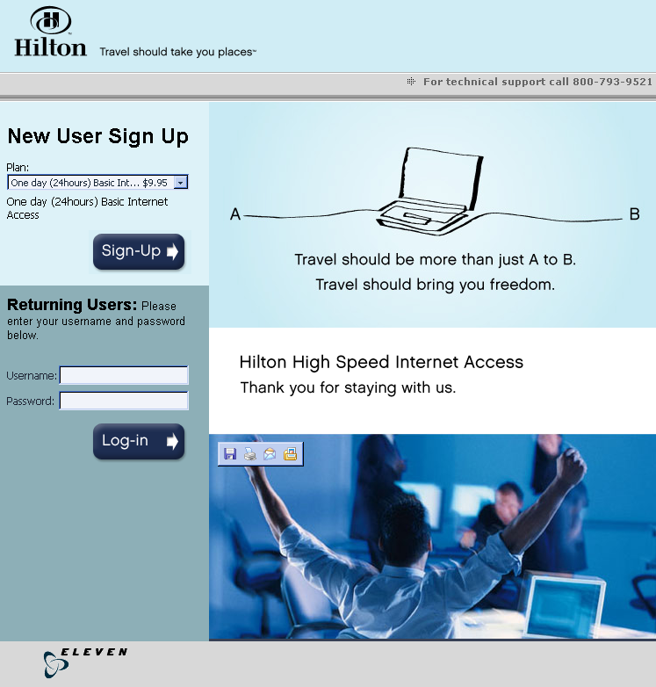

New Users must go through creating an account. Below that Returning Users can enter their username and password and press login at the top left. They will only need to do so if switching computers as they will automatically be logged back in if their MAC address is the same as the last time they logged in or the cookie stored on their computer tell Eleven Wireless it is the same computer.
  - If they choose Sign-Up, they will see the following screen.

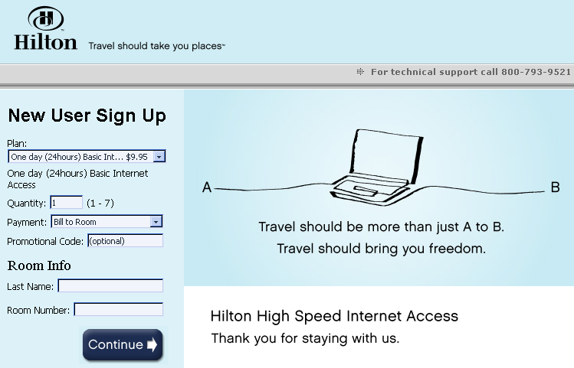

They will be given a choice of plans. If they choose a plan it Will give a more detailed description of the plan below the plan. Last name and Room number are required for 2-way PMS billing.
If they choose to pay with a credit card, they will see this screen.

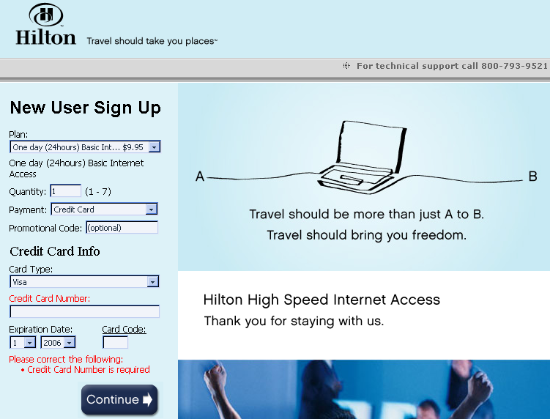

Only the Last Name and Room Number are required if they are billing to their room. For Credit Cards, they must enter all information requested, and it must match exactly with what their credit card company has on file for the charges to go through.

Once they have entered all of the information, they must press Continue.
  - The guest will now be taken to the following page to create their username and password.

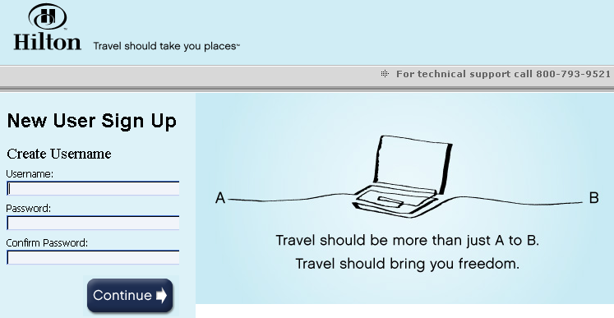

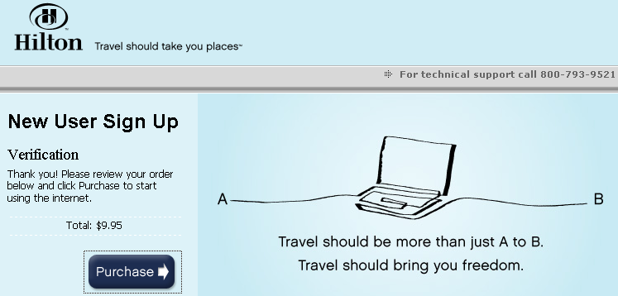
Once they have created their account successfully, they will see the following.

  - After logging, the guest will see a small popup window that tells them how much time they have left and gives them a logout button. They must use the logout button if they want to switch between wired and wireless and do not want to wait 30 minutes for the login to timeout.

  - Once a guest’s service has expired, they may add more time simply by attempting to login. They will get a message that their service has expired with a link to add additional service to the account. They will have to go back through the same screens as before to select a plan and purchase it.

Datanamics Login and Support

Login and Navigation

  - To login to Eleven Wireless, go to https://secure.elevenwireless.com and enter you username and password for Eleven Wireless. If you do not have a login, see your supervisor to get one.
  - Once logged into Eleven Wireless, you should see this screen.

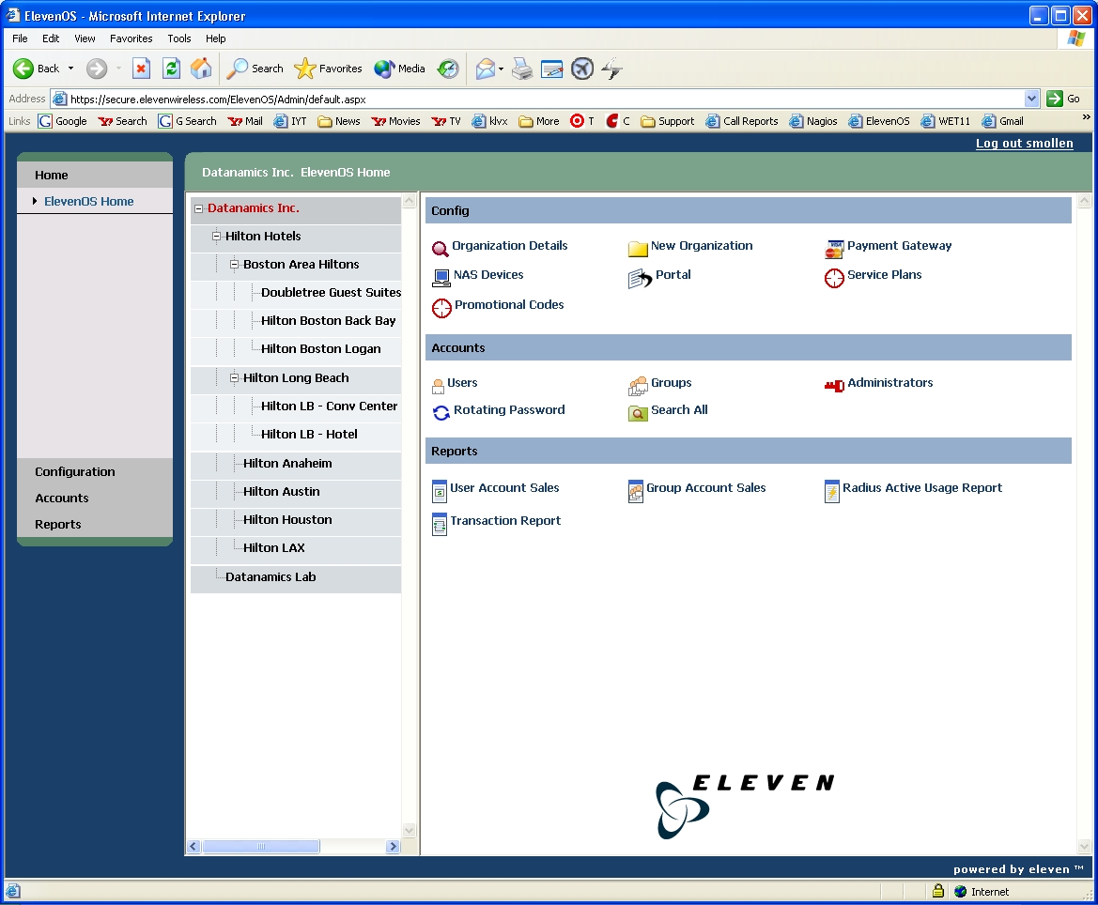

The center column has an expandable tree of the hotels that are currently using Eleven Wireless. To view user accounts and information for a specific hotel, click on it from the list, and the name should turn red.

  - The right side of the screen has a list of options for the selected hotel. To get back to this screen at any time, simply click the ElevenOS Home link at the top left. You can navigate to the same options from the menu on the left.

Searching and Viewing User Accounts

  - From the main screen, select the hotel and then click Users under Accounts on the right to get to this screen.

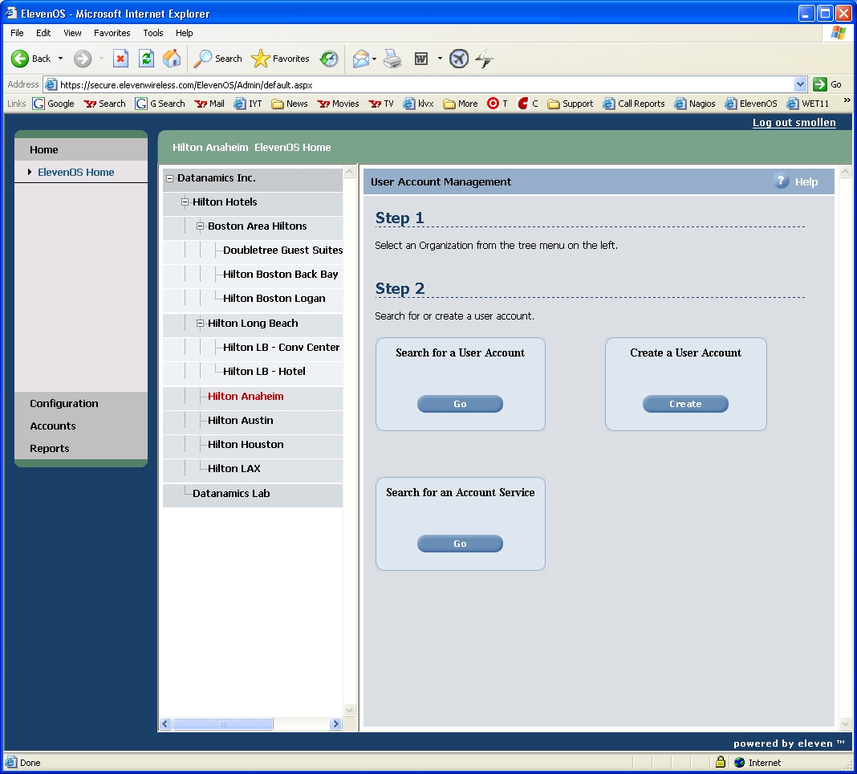

  - Click Go under Search for an Account Service to get to the next screen.

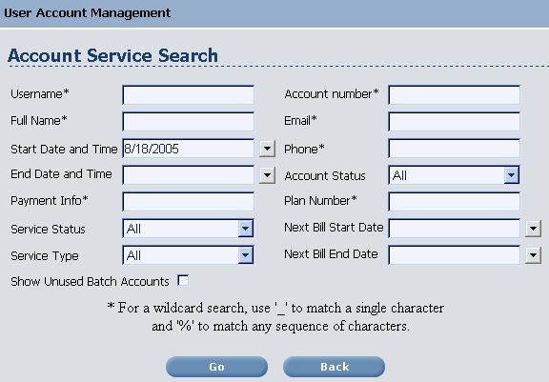

  - Search on any of the fields to find a specific account. Full name, email, and phone number are only required when paying with a credit card. Payment Info would allow you to search by name or room number if they billed it to their room.
  - Once you have run a search, you will see a window similar to this.

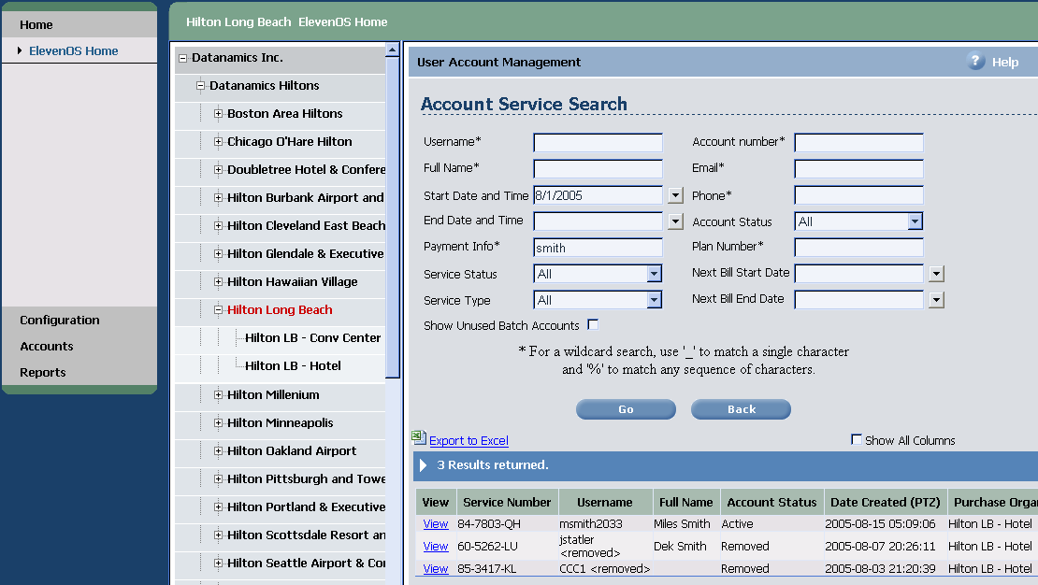

  - To view the account service details, click the View link to the left of it to get this screen.
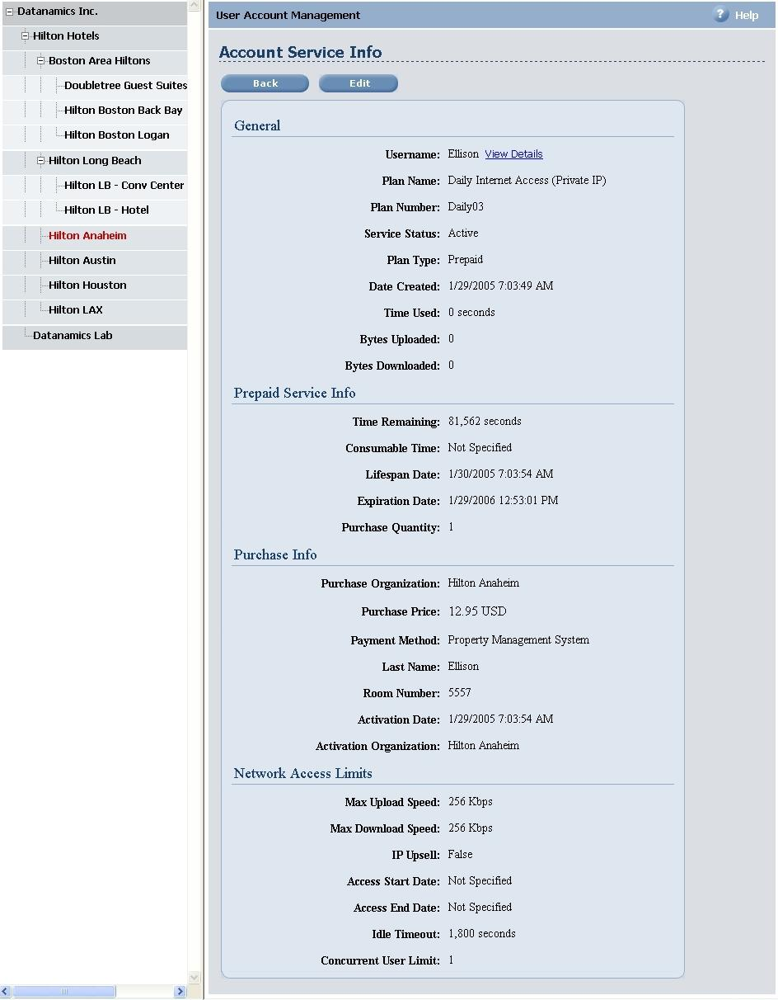
The Lifespan Date is the date their internet service will expire. The Expiration Date is date when the user account will expire; notice it is a year later. If the Consumable Time and Lifespan Date fields are blank, the guest has not logged in and activated the service yet (Time Remaining will be counting down from 31,557,600 seconds as well).
  - Click the Edit button for a specific service to make any changes.
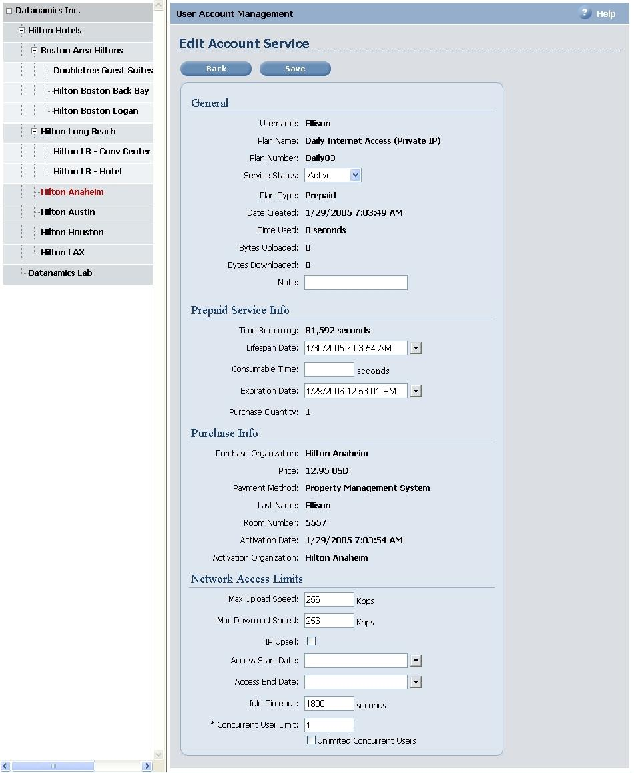
  - To change the length of their internet service, modify the Lifespan Date. Leave the Expiration Date the same as that only affects when the account will expire.
  - To view the account details, click the View details link from the Account Services Info page.
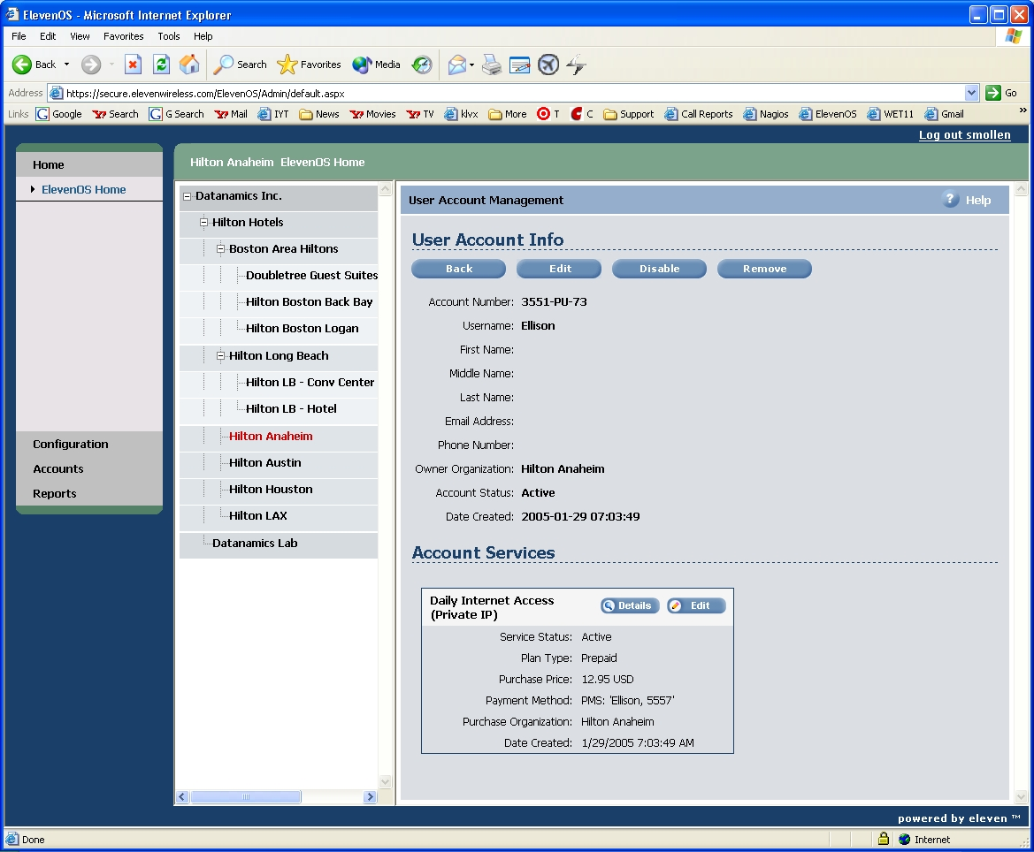

The top section shows the details for the user account. The bottom shows the details for any service plans they have purchased, including how they paid for the service and whether the service is active or expired.

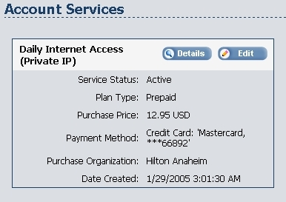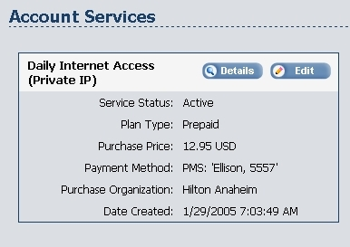

If they have purchased multiple services under the same account, you will see this, but they can have only one active service at a time.

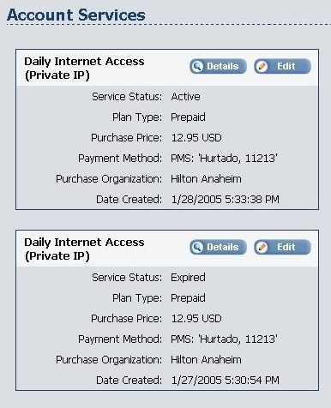

  - Click the Edit button under User Account Info to change any details of their account.

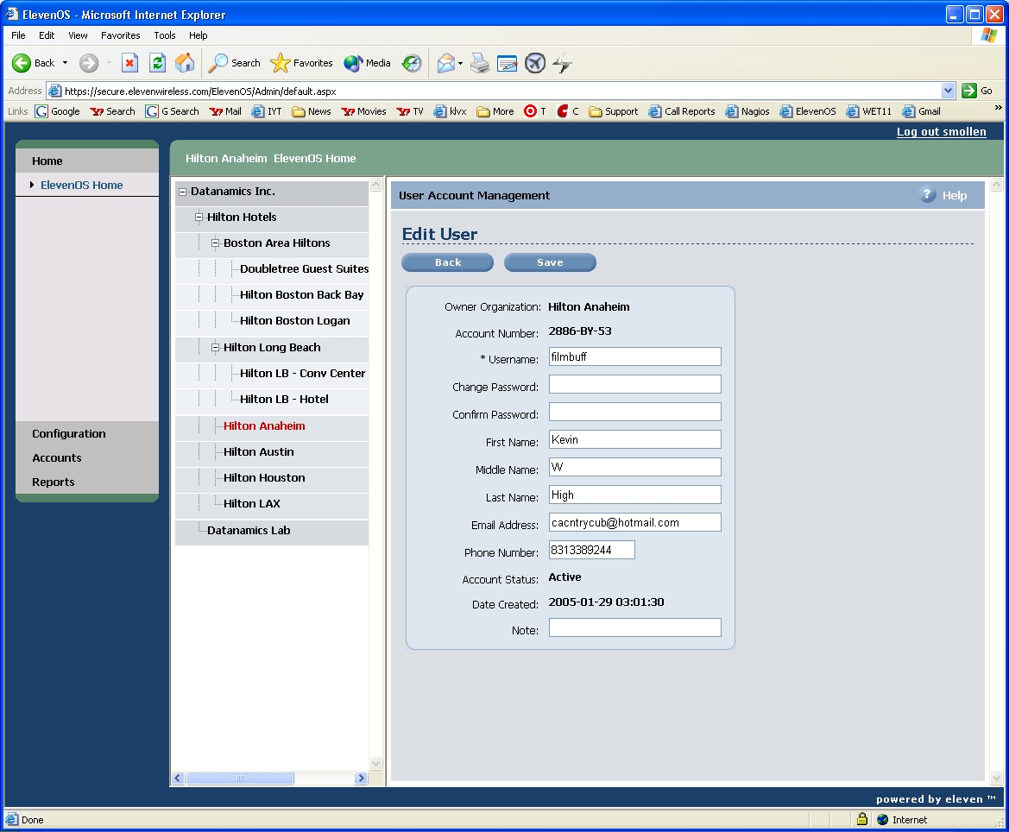

Creating an Account

  - From the main screen, select the hotel and then click Users under Accounts on the right. On the next screen, click Create under Create a User Account to get to this screen.

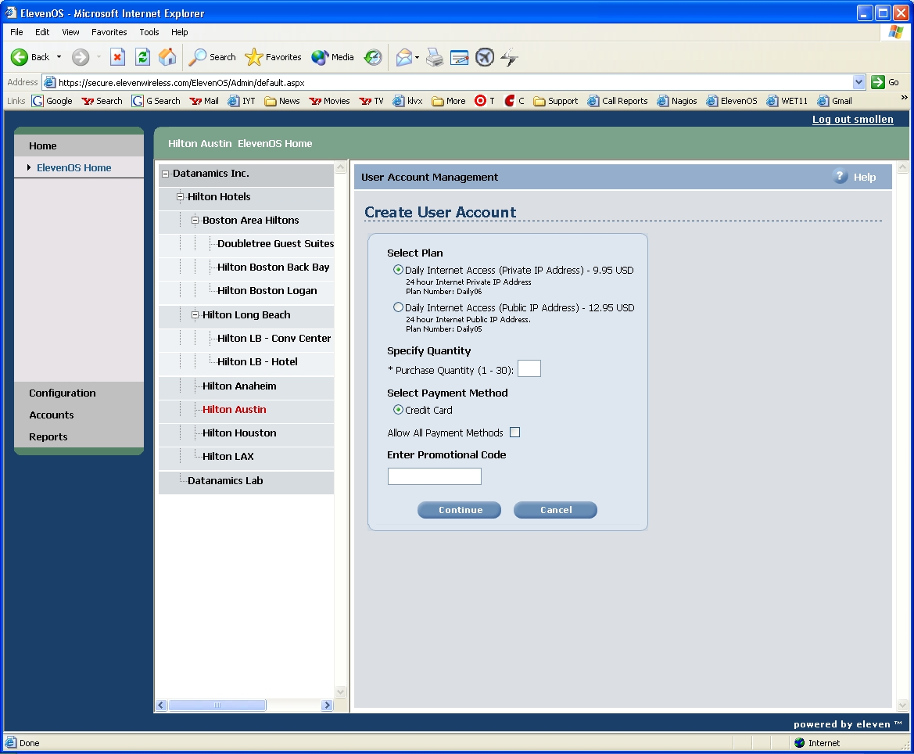

  - Select the plan the guest would like. Enter in the Quantity. Check the box to Allow All Payment Methods, and then select Free under Payment Method.

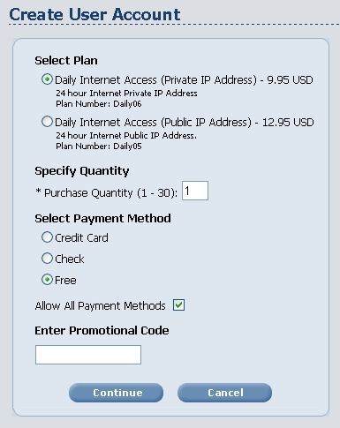

DO NOT use the Check or Credit Card options. Press the Continue Button to proceed
  - Enter the Username and Password the guest would like to use, and then press Create.

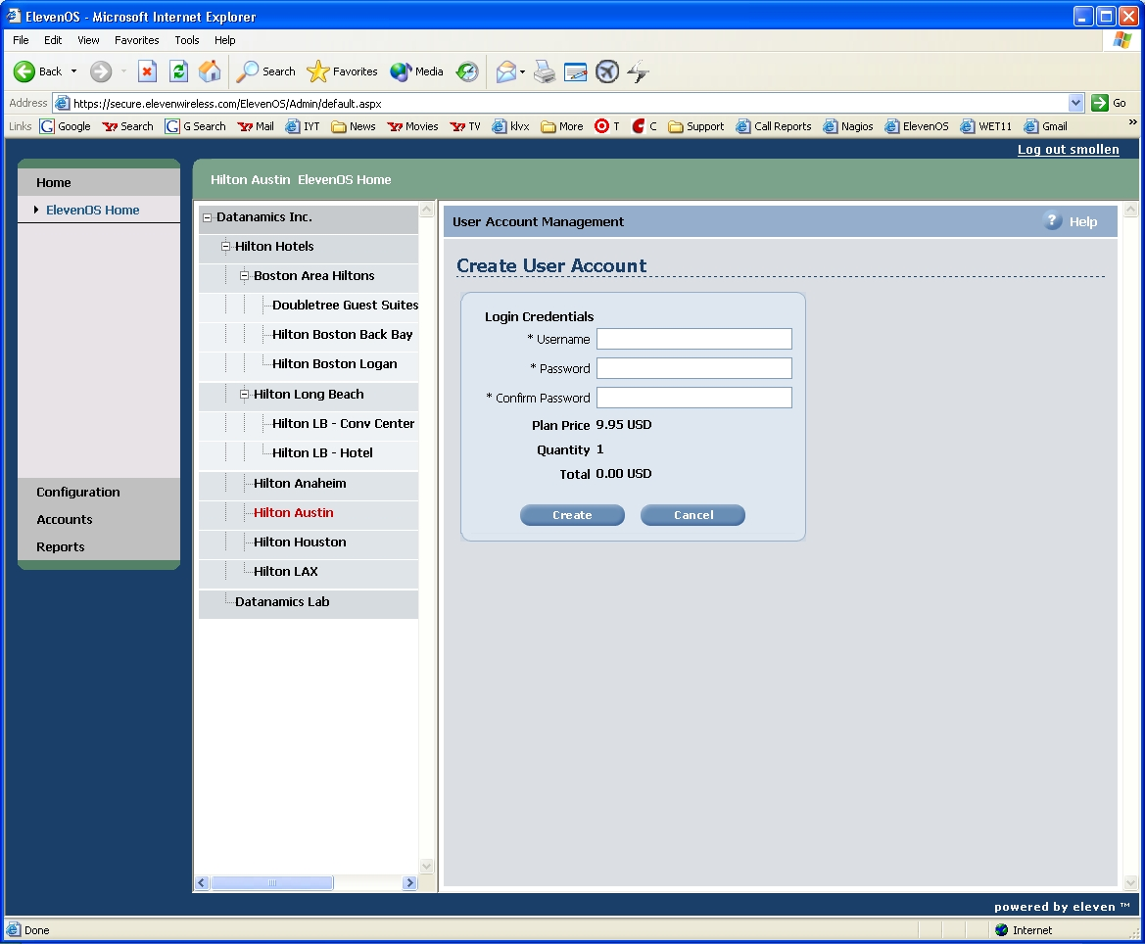

  - This screen will load to confirm the account was created. The guest should be able to login now. Press Continue to return to the User Account Management screen.

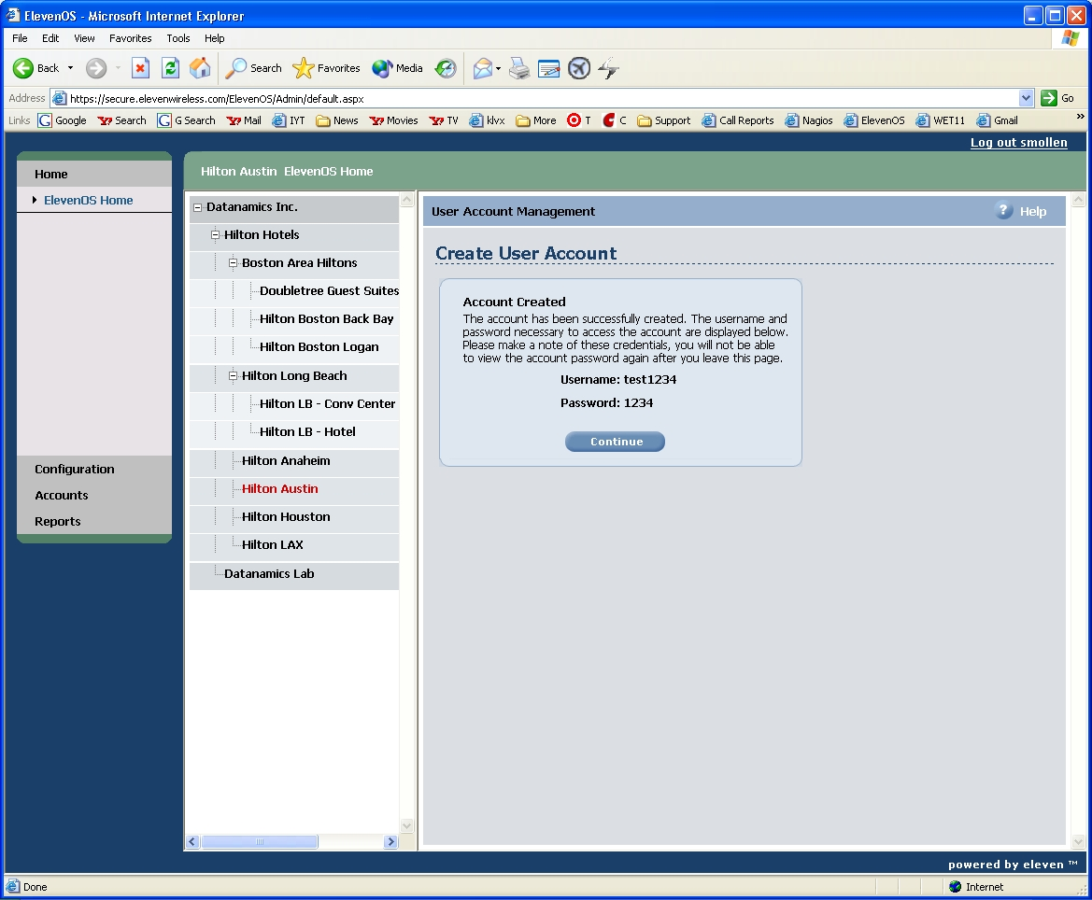

Eleven Wireless Errors & Messages

  - Maximum Number of Concurrent Connections Exceeded – The guest is either trying to use 2 PCs with the same account or trying to switch between wired and wireless. If they are trying to use 2 PCs, they must sign up for a second account. If they are trying to switch between wired and wireless, search for the username on the current list of the USG and delete and MAC addresses that you find. They guest will then be able to login. This can also occur if the guest has both wired and wireless and both are connected at the same time. Have them disable one connection, and then follow the same steps as above.
  - Last Name Does Not Match Room Number or Credit Card Not on File – Have the guest try again. They must login with the name of the primary guest on the room account, and that guest must have a credit card on file.
  - Service Has Expired – The guest will need to purchase more time. Have them scroll down further on that page, and they will see a link that will allow them to add more to time to their current account.
  - Authentication Has Started But Not Completed – Have the guest close IE and reopen to try logging in again. If the problem persists, escalate the call to 2nd level immediately. This can indicate a serious problem with the Eleven Wireless system, and if it is affecting other guests and/or hotels, AAA may need to be disabled until it is resolved.
  - Credit Card Receipt – If they pay with a credit card, they will get the following receipt by email.

Internet Access Receipt
Thank you for purchasing Internet access. Please keep this email as it
is your receipt and contains your account information.
Username: LAXtest
Location Purchased: Hilton Long Beach
Purchase Method: Credit Card
Time Purchased: Unlimited
Purchase Price: 9.95 USD
Purchase Date: Aug 20 2004 11:25AM PST
This account will expire 1 Days after first use.
This account is not valid after Aug 20, 2005.
Thank you for visiting the Hilton Long Beach. For all billing matters, please contact the hotel directly.

